Review of project

**Name of the project: Library Management**

**Project Statement**

* The library management website is designed with the help of PHP. Cypress is the testing tool of this project.
* Scope of this project is related to collection of library books to create the record of books which is available into library.
* To add that books into the data base.

**Introduction:**

In this project, there are options of delete and add the book into the data base. One can check the title of the book and name of author. There is also a feature of check the publication name of a book, price and the year of the books.

**Test Cases:**

* Edit current books: Test Pass

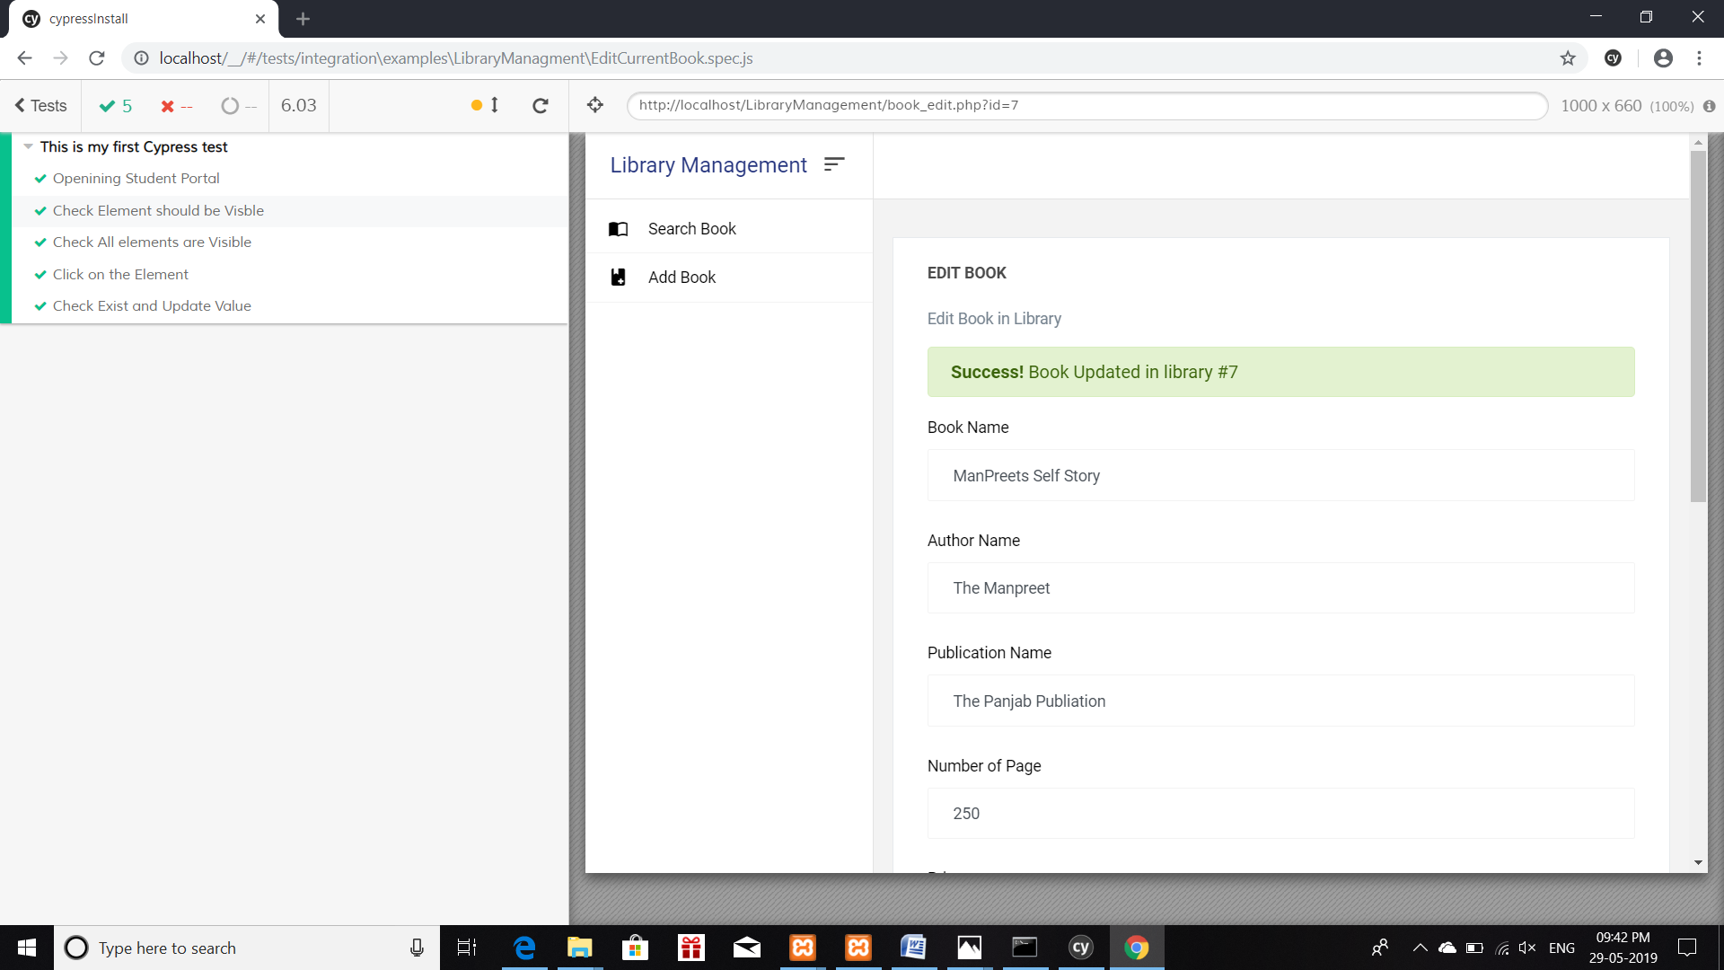

* Add Book to Library: Test Pass

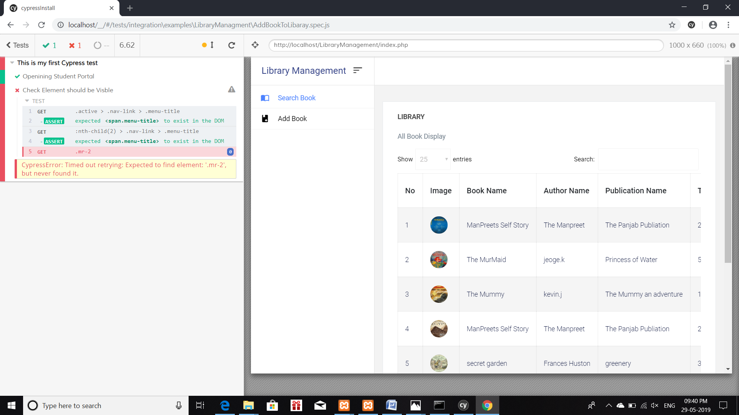

* Testing validation in library management: Test Pass

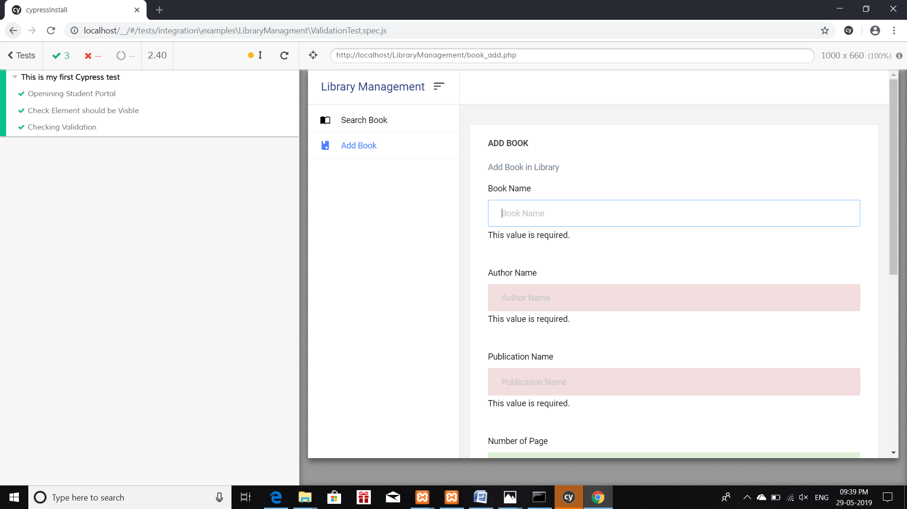

ss**Git hub link**: <https://github.com/manpreetstudent/studentportalmanpreet.git>

Pipe line: Job is not created because the server is not available. It also shows error to open Jenkins account.